
Major Project Progress Report On
“Landslide Detection using Deep Learning Models”

SUBMITTED BY:
Vineet Patel (202200530) Pratham Mir Dutraj (202200521)

Department of Information Technology SESSION: 2025 - 2026
Under the guidance of
Mrs. Sonam Lhamu Bhutia

Designation

DEPARTMENT OF INFORMATION TECHNOLOGY SIKKIM MANIPAL INSTITUTE OF TECHNOLOGY
Majitar, Rangpo, East Sikkim-737136

ABSTRACT

A deep learning-based approach was applied for the classification of landslides using the Landslide4Sense dataset, ( 128x128 pixels) and corresponding binary masks. Convolutional Neural Networks (CNNs), potentially including architectures like ResNet or Vision Transformers (ViT), were trained on pre-processed data involving feature extraction such as RGB channels, Normalized Difference Vegetation Index (NDVI) from near-infrared (NIR) and red bands, and terrain attributes (e.g., digital elevation model channels). Data preprocessing steps included loading HDF5 files via h5py, normalization, and augmentation to handle class imbalance and improve model robustness. By automating multi- channel feature extraction, the need for manual interpretation was minimized, enhancing efficiency and scalability for landslide detection.
The trained models were evaluated using metrics such as accuracy, precision, recall, and F1-score, demonstrating superior performance over traditional machine learning methods. Landslides were segmented and classified into binary categories (landslide vs. non-landslide) with high reliability, highlighting the potential of deep learning for real-world hazard management and risk assessment. The results indicate that this CNN-based classification and segmentation can support early warning systems and contribute to disaster mitigation strategies.

TABLE OF CONTENTS

SL.No | Title | Pg.No
1 | Introduction | 1
2 | Types of Landslides | 2-3
3 | Literature Survey | 4-6
4 | Problem Defination | 7
5 | Objective | 8
6 | Pseudocode/Algorithm | 9-11
7 | Methodology | 12-14
8 | Solution Strategy | 15
9 | Dataset Description | 16
10 | Hardware and Software Requirements | 17
11 | Workdone | 18
12 | Gant Chart | 19
13 | Reference | 20

INTRODUCTION

Landslides are frequent and destructive natural hazards, causing significant loss of life, property damage, and environmental disruption [1]. Triggered by geological, hydrological, and climatic factors such as heavy rainfall, earthquakes, and human activities like deforestation, their risks are escalating due to climate change and urban expansion in hilly regions [2]. Traditional methods, including field surveys and manual satellite image analysis, are time-consuming and limited in handling large-scale geospatial data [1]. This project employs a deep learning-based approach using a U-Net Convolutional Neural Network (CNN) to classify landslide-prone areas, leveraging remote sensing and terrain data in .hy format for efficient high-dimensional feature processing [2]. The model, trained on 128x128x6 datasets with dropout regularization and sigmoid activation, uses the Adam optimizer and binary cross-entropy loss, monitored by ModelCheckpoint for the best validation F1-score. Performance is evaluated with accuracy, precision, recall, and F1-score metrics, visualized through epoch-wise plots of loss and custom metrics, offering a scalable solution for rapid landslide hazard assessment [3, 2].

TYPES OF LANDSLIDES
- Falls:
Falls involve the sudden detachment and free movement of rock, soil, or debris from a steep slope or cliff.
Materials move almost vertically, dropping through the air and collecting at the base of the slope.Weathering, freeze–thaw action, earthquakes, or heavy rainfall that loosen material.Accumulation of rock fragments (talus) at the foot of a cliff; cracks near cliff edges.Can be very fast and destructive, especially in mountainous terrains with steep rock faces.

- Slides(Rotational):
Slides involve the downslope movement of soil, rock, or debris along a distinct plane of weakness (slip surface).Material moves along a curved surface, causing backward tilting of blocks.
Material moves along a flat or planar surface, often as large blocks.Heavy rainfall, earthquakes, erosion at the slope base, deforestation, or construction activities.Tension cracks, tilted trees/poles, scarps, and displaced ground.Can damage roads, houses, and farmland; sometimes slower than falls but can involve huge masses of earth.

- Topples:
Topples occur when a block of rock or soil tilts forward and rotates out of the slope.
Rotation occurs around a pivot point (often near the base).Undercutting of slopes, water seepage, freeze–thaw, earthquakes, or gravity acting on overhanging material.Leaning rocks, cracks behind blocks, overhanging cliffs.Usually localized but can trigger rockfalls or secondary slides.

- Flows:
Flows occur when loose, water-saturated soil, rock, or debris behaves like a viscous fluid and moves downslope.Fast, carries boulders, trees, and debris mixed with water.Finer particles (silt/clay) dominate, moving like wet cement.Slower, involves cohesive soil masses.Intense rainfall, snowmelt, or volcanic activity (lahars).Bulging toes at slope base, lobes of soil, and wet, hummocky terrain.Can be rapid, destructive, and long-traveling, burying settlements and infrastructure.

- Spreads (Lateral Spreads):
Lateral spreads occur when intact soil or rock blocks move horizontally, usually over an underlying weakened or liquefied layer.Extension and fracturing, with blocks drifting apart; often looks like the ground “tearing apart.”Earthquake-induced liquefaction, river undercutting, flooding, or water-saturated weak soils.Wide ground fissures, tilted structures, and horizontal displacements.Particularly damaging to infrastructure like roads, railways, and pipelines; affects large, flat terrain near rivers or coasts.
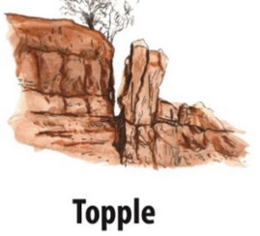
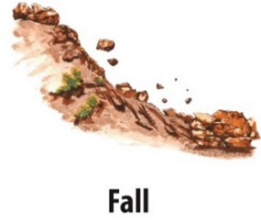
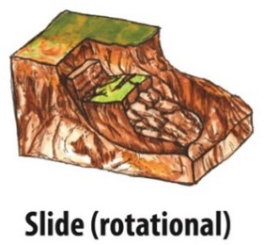
Fig: 1.1 Fig: 1.2 Fig: 1.3

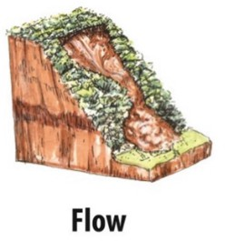

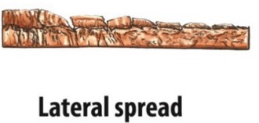

Fig: 1.4 Fig:1. 5

LITERATURE SURVEY

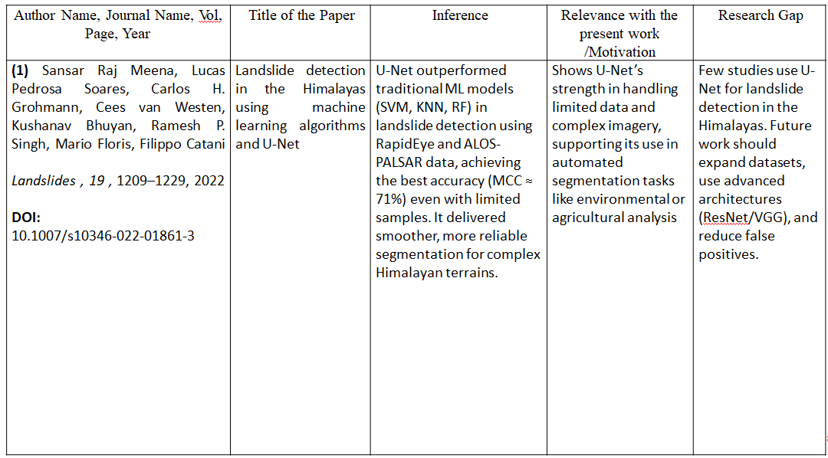

LITERATURE SURVEY

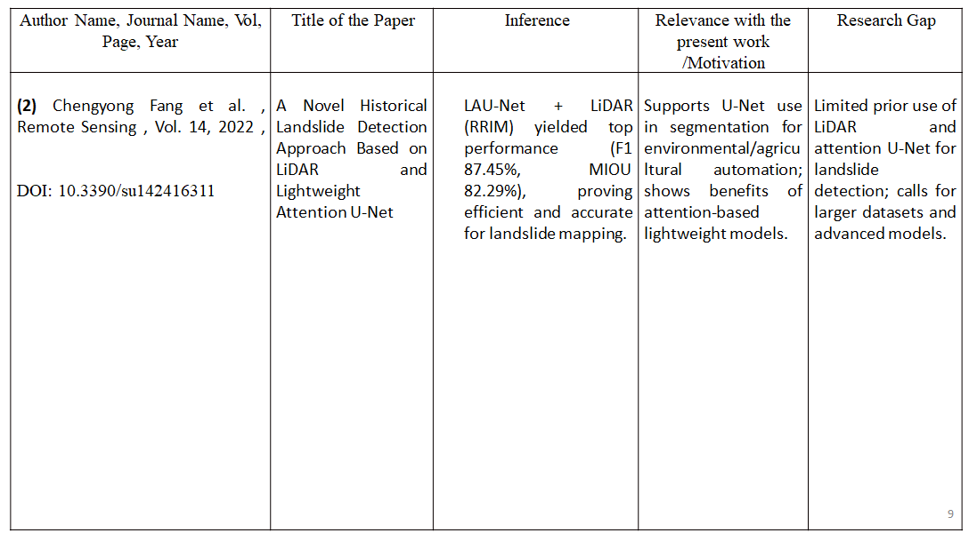


LITERATURE SURVEY

PROBLEM DEFINITION

Landslides pose a persistent and severe natural hazard, resulting in significant loss of life, property damage, and ecological disruption [1]. These events are driven by a complex interplay of geological, hydrological, and climatic factors, including heavy rainfall, seismic activity, and human-induced changes such as deforestation and construction. The increasing risks, exacerbated by climate change and rapid urbanization in hilly terrains, necessitate advanced monitoring and predictive tools [2]. Conventional approaches, such as field surveys and manual analysis of satellite imagery, are labor-intensive, time-consuming, and inadequate for processing extensive geospatial datasets [1]. This project addresses these challenges by formulating a deep learning-based problem to classify landslide-prone regions using remote sensing and terrain data in .hy format, which efficiently handles high-dimensional features. A U-Net Convolutional Neural Network (CNN) is designed to automatically extract spatial patterns and predict landslide susceptibility, trained on 128x128x6 multi-channel datasets with dropout regularization and sigmoid activation. The problem is defined to optimize model performance using the Adam optimizer and binary cross-entropy loss, with training monitored via ModelCheckpoint to retain the best model based on validation F1-score. Evaluation focuses on accuracy, precision, recall, and F1-score, with visualizations of these metrics over epochs to assess training stability and effectiveness, aiming to provide a scalable solution for landslide hazard mapping and mitigation [3].

OBJECTIVE

- To develop an advanced deep learning framework to identify and categorize landslide-susceptible zones using remote sensing and terrain data in .hy format.

- To construct a U-Net CNN model tailored for automated spatial feature extraction from 128x128x6 multi-channel datasets, enhancing landslide detection accuracy.

- To optimize the model training process with the Adam optimizer and binary cross-entropy loss, utilizing ModelCheckpoint to preserve the highest-performing model based on validation F1-score.
- To assess model effectiveness through a comprehensive evaluation using accuracy, precision, recall, and F1-score metrics, ensuring robust performance.

- To generate visual representations of training progress, plotting loss, precision, recall, and F1-score across epochs to analyze model stability and learning trends.

- To deliver a scalable and efficient solution for landslide hazard mapping, supporting timely mitigation strategies in vulnerable regions.

PSEUDOCODE/ALGORITHM

Input:
Multispectral images containing RGB, NDVI, and Slope channels
Output:
Binary segmentation mask

Step 1: Data Preprocessing
1.1 Load training and validation datasets.
1.2 Normalize input images to the range [0, 1].
1.3 Split data into input features (x_train, x_valid) and target masks (y_train, y_valid).

Step 2: Define Custom Evaluation Metrics
2.1 Define functions for Precision, Recall, and F1-Score:
• Precision = TP / (TP + FP)
• Recall = TP / (TP + FN)
• F1 = 2 × (Precision × Recall) / (Precision + Recall)

Step 3: Build U-Net Architecture
3.1 Initialize input layer with dimensions (IMG_WIDTH, IMG_HEIGHT, IMG_CHANNELS).
3.2 Encoder Path (Contracting Path):
• Apply two convolution layers → ReLU activation → Dropout → MaxPooling.
• Double filters after each block (16 → 32 → 64 → 128 → 256).
3.3 Bottleneck Layer:
• Apply convolution → Dropout → convolution to capture deep features.
3.4 Decoder Path (Expanding Path):
• Perform upsampling using Conv2DTranspose.
• Concatenate corresponding encoder layers (skip connections).
• Apply convolution → Dropout → convolution for feature reconstruction.
3.5 Add output layer with 1×1 convolution and sigmoid activation for binary mask generation.

Step 4: Model Compilation
4.1 Compile model with:
• Optimizer: Adam
• Loss function: Binary Cross-Entropy
• Metrics: Accuracy, Precision, Recall, F1-Score

Step 5: Model Training
5.1 Train model on training data for 100 epochs with batch size 16.
5.2 Use validation data for performance monitoring.
5.3 Apply ModelCheckpoint to save the best model based on validation F1-Score.

Step 6: Model Evaluation & Visualization
6.1 Evaluate model on validation dataset to compute loss, accuracy, precision, recall, and F1-score.
6.2 Plot training vs validation curves for loss and metrics.
6.3 Visualize predicted masks alongside RGB, NDVI, and Slope inputs.

Step 7: Model Saving
7.1 Save best-performing model as best_model.h5.
7.2 Save final trained model as model_save.h5 for future use or deployment.

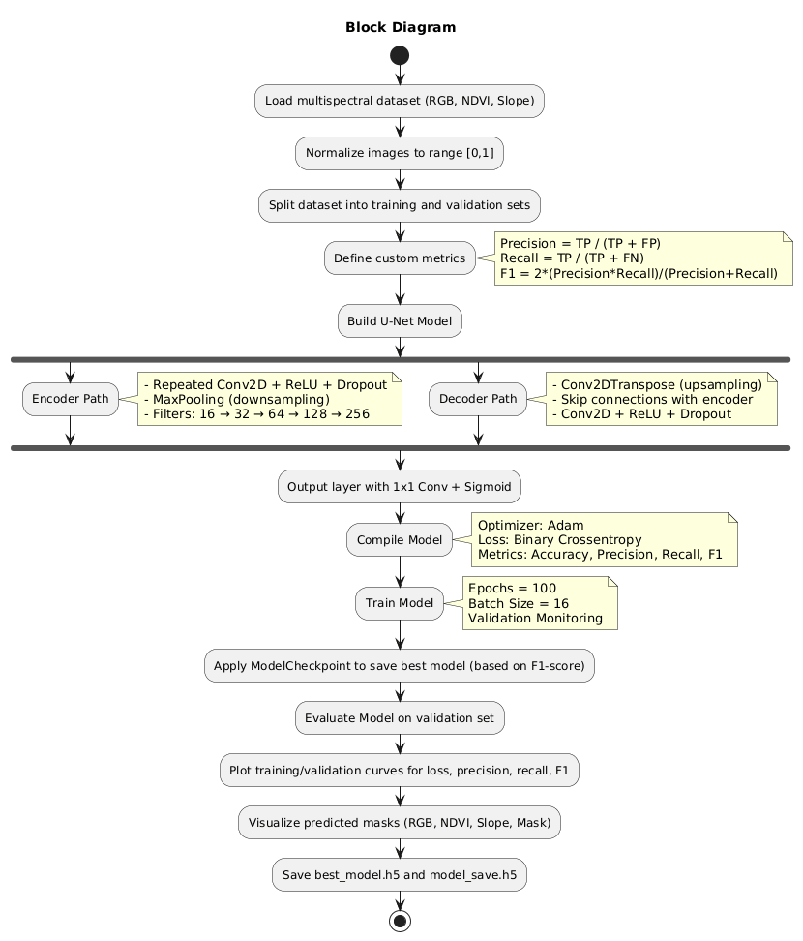

METHODOLOGY

- Data Collection and Preparation
  - Collected multispectral imagery consisting of RGB, NDVI, and slope data.
  - Preprocessed the dataset by resizing images and normalizing pixel values to the range [0,1].
  - Divided the dataset into training and validation sets to ensure unbiased performance evaluation.

- Feature Visualization
  - Visualized different input channels (RGB, NDVI, Slope) and their corresponding ground truth masks.
  - This step helped in understanding the data distribution and spatial patterns for segmentation.

- Model Architecture Design (U-Net)
  - Implemented a U-Net model using TensorFlow and Keras for pixel-wise segmentation.
  - The encoder path captures spatial features using convolutional layers and max pooling.
  - The decoder path reconstructs the segmentation map using transposed convolutions and skip connections.
  - Dropout layers were added to reduce overfitting, and ReLU activations were used for non-linearity.

- Model Compilation
  - The model was compiled using the Adam optimizer and binary cross-entropy loss function.
  - Performance metrics such as Precision, Recall, F1-Score, and Accuracy were included for comprehensive evaluation.

- Training Process
  - The network was trained for 100 epochs with a batch size of 16.
  - Validation data was used during training to monitor performance and prevent overfitting.
  - A ModelCheckpoint callback was employed to save the best-performing model based on the validation F1-score.

- Evaluation and Visualization
  - After training, the model was evaluated on the validation dataset using all defined metrics.
  - Performance curves (loss, precision, recall, F1-score) were plotted to analyze learning trends.
  - Predicted segmentation masks were visualized alongside RGB, NDVI, and Slope images for qualitative assessment.
- Model Saving and Deployment
  - The best-performing model weights were saved as best_model.h5, and the final model as model_save.h5.
  - These models can be further fine-tuned, deployed for prediction, or integrated into a web-based segmentation system.

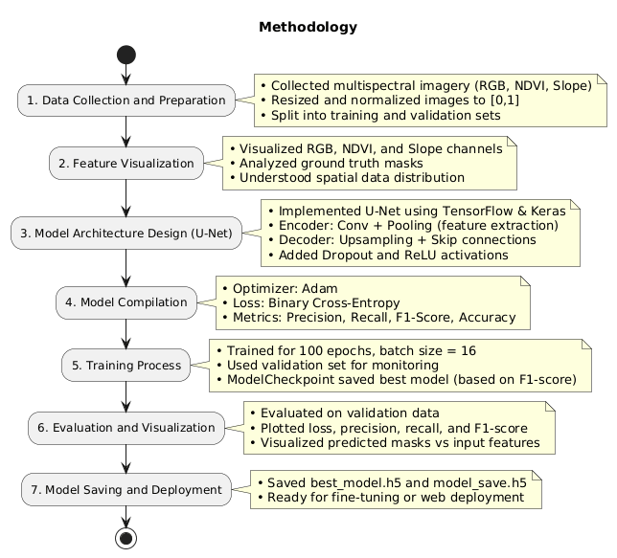

SOLUTION STRATEGY
.
- The project’s main goal was to design a deep learning-based image segmentation model using the U-Net architecture to accurately detect regions of interest from multispectral data.
- The dataset included RGB, NDVI, and slope layers, which together provided diverse spatial and spectral information for better segmentation results.
- Before training, all input images were normalized to a [0,1] range to improve model stability and ensure consistent data scaling.
- The U-Net model followed an encoder-decoder structure, where the encoder captured deep spatial features and the decoder reconstructed detailed segmentation maps.
- Skip connections were used to retain important spatial details that might otherwise be lost during downsampling.
- Dropout layers were added throughout the network to prevent overfitting and improve the model’s generalization ability.
- The ReLU activation function was applied to enable efficient non-linear feature learning during training.
- The model was compiled with the Adam optimizer and a binary cross-entropy loss function, while precision, recall, and F1-score were used for a more well-rounded performance evaluation.
- A ModelCheckpoint callback automatically saved the best-performing model weights based on the validation F1-score, ensuring optimal results.
- • The network was trained for 100 epochs with a batch size of 16, and its training and validation metrics were closely analyzed. The final model was evaluated, saved, and visualized to confirm its accuracy and reliability in multispectral image segmentation.

DATASET DESCRIPTION

DATASET LINK : Classification for Landslide Detection (Kaggle)

MAIN FOLDER NAME :

Classification for Landslide (Total number of images present in this folder: 12,544) Total Size 4.93 GB

SUB FOLDER DETAILS :

train_data:
Contains the training images used for model development.
Images are organized with corresponding labels provided in Train.csv. Format available: .jpg (raw images), .npy (preprocessed NumPy arrays).
test_data:
Contains the testing images used for model evaluation.
Labels are not directly given; they are used for submission and verification. Format available: .jpg, .npy.

IMAGE SIZE :
Each image is standardized to 256 × 256
pixels Width: 256 pixels
Height: 256 pixels
Horizontal Resolution: 96 dpi Vertical
Resolution: 96 dpi Bit

HARDWARE & SOFTWARE REQUIREMENTS

Hardware Requirements

- Processor (CPU): Intel/AMD , with support for GPU acceleration

- GPU: High performance GPU (e.g., NVIDIA and RYZEN ); integrated GPU sufficient for basic tasks.
- RAM: 8 GB (min), 16 GB or more (recommended for handling large HDF5 datasets smoothly).
- Storage: 256 GB SSD (min), with cloud storage integration (e.g., Google Drive) for datasets.

Software Requirements

- Operating System: Windows , Linux-based (e.g., Google Colab). Programming
- Environment Libraries & Frameworks: Python 3.12.3 (installed via Colab).
- Machine Learning: TensorFlow (for CNN models), architecture U-Net NumPy, Pandas, Matplotlib.
- Image Processing: h5py (for HDF5 handling), glob (for file management). Data Handling & Visualization: Matplotlib .
- IDE / Tools: Google Colab (Jupyter-based), with Google Drive mounting for data access.
- Package Manager: pip (for installing TensorFlow and Matplotlib).
- Version Control: Git (integrated with Colab

WORKDONE

- Implemented a deep learning-based image segmentation system using the U-Net architecture on multispectral imagery data, including RGB, NDVI, and slope layers.
- Performed data preprocessing by resizing images, normalizing pixel values to [0,1], and splitting the dataset into training and validation subsets.
- Built the U-Net model in TensorFlow and Keras, incorporating convolutional, pooling, and transposed convolution layers, with dropout and ReLU activations to enhance learning and reduce overfitting.
- Trained the model for 100 epochs (batch size 16) using the Adam optimizer and binary cross-entropy loss, evaluating with metrics such as Precision, Recall, F1-Score, and Accuracy while saving the best model via ModelCheckpoint.
- Evaluated performance through quantitative metrics and visual comparisons of predicted masks with RGB, NDVI, and slope layers, confirming the U-Net model’s effectiveness in multispectral image segmentation.

GANTT CHART

ACTIVITY | TIMEFRAME
 | Aug 2025 | Sep 2025 |  | Oct 2025 |  |  | Nov-Dec 2025
Literature Survey
Problem defination and solution startergy
Data collection and preprocessing
Devlopment of Model
Testing and Validation
Documentation

Completed
Not Completed

REFERENCE

(1)Sansar Raj Meena, Lucas Pedrosa Soares, Carlos H. Grohmann, Cees van Westen, Kushanav Bhuyan, Ramesh P. Singh, Mario Floris, Filippo CataniLandslides , 19 , 1209–1229, 2022DOI: 10.1007/s10346-022-01861-3

(2)Chengyong Fang et al. , Remote Sensing , Vol. 14, 2022 , DOI: 10.3390/su142416311

(3) Lucas P. Soares, Helen C. Dias, Carlos H. Grohmann,2020 DOI: 10.1007/s11042-024-19454-8

